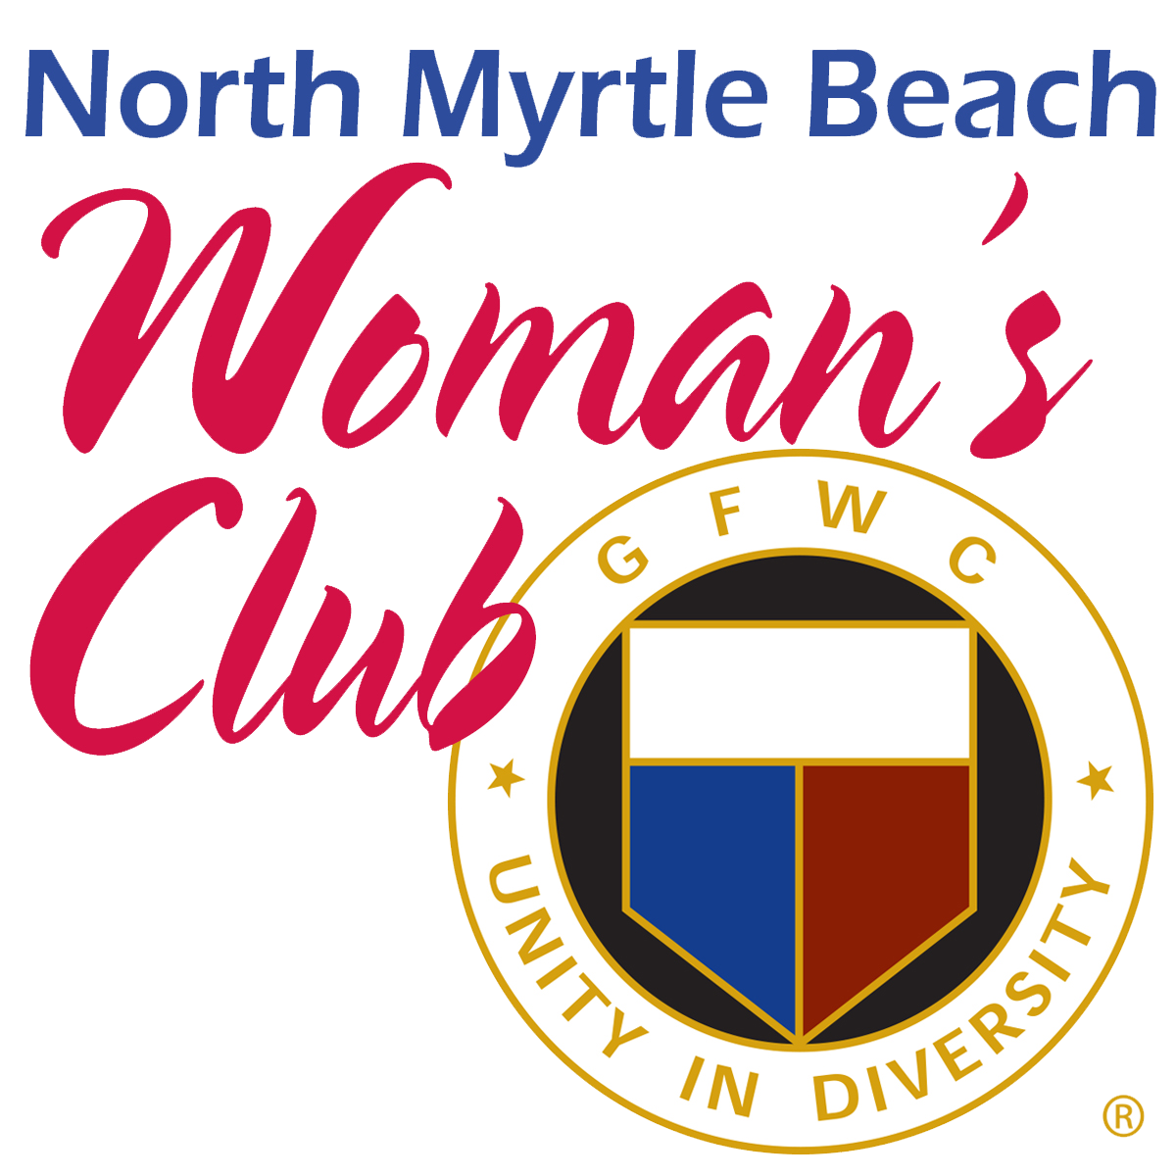**-** **Guest Information -** photo **Membership Application**

Name_______________________________________________________________ Date______________

Mailing Address (required)___________________________________________________________________ City_______________________ State____ Zip________ Email (required)_____________________________ Spouse/Partner____________________________ Birthday: Month/Day *only* (required)__________________

Phone (required)_____________________________ Cell Phone (required)_____________________________

Occupation/Business/Retiree/Other__________________________________________________________

Brief Bio (including any prior Woman’s Club involvement)_________________________________________

______________________________________________________________________________________

______________________________________________________________________________________

______________________________________________________________________________________ Sponsor: NMBWC Club Member’s Name (required)_______________________________________________

Please submit this completed Form with all required information to the NMBWC Membership Vice President along with a $35.00 nonrefundable initiation fee which covers your NMBWC Handbook, and personalized name badge. After the NMBWC Board of Directors approves your application, you will pay pro-rated dues up to $55.00 that are due immediately. Annual membership dues are $55 and payable May 1 through May 31. Make checks payable to the North Myrtle Beach Woman’s Club. The mailing address is P.O. Box 711, North Myrtle Beach SC 29597. Additional information is available on the official website at <http://www.northmyrtlebeachwomansclub.org/>.

DO NOT WRITE BELOW THIS LINE: *For Administrative Use Only!*

1st Mtg attended_________________ 2nd Mtg attended____________________ 3rd Mtg attended_________________

How did guest/member hear about NMBWC? __Website __Facebook __Publication __Member __Club Event __Other

Date application received________________ Date $35 application fee received_______________ Cash___ Check____

Date $55 membership dues received________________ Cash___ Ck___ Date Membership Pin Ordered_____________

North Myrtle Beach Woman’s Club Yearbook August 2024